Product Design Specification

Programming 3 AT3

Tze yee hon – p466426

2019

Contents

Introduction 2

Purpose of the product design specification document 2

Architecture Design 2

Hardware Architecture 2

Software Architecture 2

System Design 3

Use Cases 3

Login form 3

Main form 3

Graphic Interface Design 3

Login form 3

Main form 3

Product Design Specification Approval 4

# Introduction

## Purpose of the product design specification document

The purpose of the product design specification document is to create a program which include the techniques that used in this semester.

# Architecture Design

The program has 2 forms – Login form and main form

The login form will require user to sign up an account then user the registered account to login into main form. The main form will display after logged in and allow user to use the function of main form

## Hardware Architecture

The minimum hardware requirement if this program as following:

* 1.8GhHz processor or faster processor
* 2GB of RAM; 8GB of RAM recommended
* Minimum of 800MB up to 210GB of available hard disk space
* Video card minimum display resolution of 1280x720p

## Software Architecture

The software required for this program as following:

* Microsoft Visual Studio
* Microsoft Windows operating system (64-bit recommended)

# System Design

## Use Cases

### Login form

* Sign up a new account by insert id and password
* Login into main form via account signed up

### Main form

* Create new item by insert game title, platform and genre
* Use add button when wants to create a new item
* Search button allows user to search items from list
* Sort button allows user to sort items by ascending order
* Save button allows user to save data as csv files
* Open button allows user to open file dialog and open selected csv file

## Graphic Interface Design

### Login form

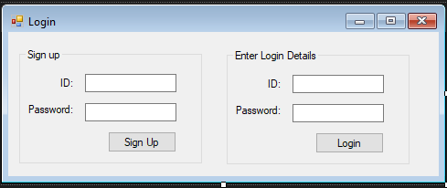

### Main form

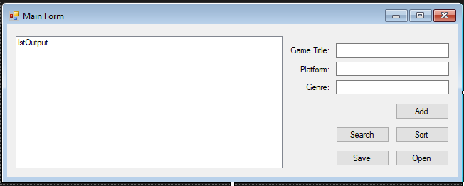

# Product Design Specification Approval

The undersigned acknowledge they have reviewed the Programming 3 – AT3 product design specification document and agree with the approach it presents. Any changes to this requirements definition will be coordinated with and approved by undersigned or their designated representatives

|  |  |  |  |
| --- | --- | --- | --- |
| Signature: |  | Date: |  |
| Print Name: |  |  |  |
| Title: |  |  |  |
| Role: |  |  |  |

|  |  |  |  |
| --- | --- | --- | --- |
| Signature: |  | Date: |  |
| Print Name: |  |  |  |
| Title: |  |  |  |
| Role: |  |  |  |

|  |  |  |  |
| --- | --- | --- | --- |
| Signature: |  | Date: |  |
| Print Name: |  |  |  |
| Title: |  |  |  |
| Role: |  |  |  |

# Bibliography

*How to write a produc specification document: Example*. (n.d.). Retrieved from study.com: https://study.com/academy/lesson/how-to-write-a-product-specification-document-examples.html

*Product Design Specification*. (n.d.). Retrieved from ScienceDirect: https://www.sciencedirect.com/topics/engineering/product-design-specification

*Session 10 - Testing*. (n.d.). Retrieved from South Metropolitan TAFE: https://blackboard.southmetrotafe.wa.edu.au/webapps/blackboard/content/listContent.jsp?course_id=_12140_1&content_id=_1170302_1